%%********************************************************************%%
%%--------------------------Input Parameters--------------------------%%
%%********************************************************************%%
Rhub = 0.0538/2; %[m], Hub radius (common for both propellers)
R1 = 0.191/2; %[m], Propeller radius front prop
R2 = 0.191/2; %[m], Propeller radius back prop
M1 = 10; %[ ], Number of vortex panels over the radius front prop
M2 = 10; %[ ], Number of vortex panels over the radius back prop
Z1 = 2; %[ ], Number of blades front prop
Z2 = 2; %[ ], Number of blades back prop
Tr = 200; %[N], Required total thrust
q = 1; %[ ], torque ratio Q2/Q1
N1 = 1500; %[RPM], Propeller speed front prop
N2 = 1500; %[RPM], Propeller speed back prop
XR1 = [0.2,0.3,0.4,0.5,0.6,...
0.7,0.8,0.9,0.95,1]; %[ ], Radial locations for defining inflow velocities
% and geometric properties front prop
XR2 = [0.2,0.3,0.4,0.5,0.6,...
0.7,0.8,0.9,0.95,1]; %[ ], Radial locations for defining inflow velocities
% and geometri properties back prop
XCoD1 = [0.1388,0.1388,0.1388,...
0.1388,0.1388,0.1388,...
0.1388,0.1388,0.1388,0.1388];
%[0.16,0.1812,0.2024,...
%0.2196,0.2305,0.2311,...
%0.2173,0.1807,0.1388,0.001]; %[ ], chord / propeller diameter front prop
XCoD2 = [0.1388,0.1388,0.1388,...
0.1388,0.1388,0.1388,...
0.1388,0.1388,0.1388,0.1388];
%[0.16,0.1812,0.2024,...
%0.2196,0.2305,0.2311,...
%0.2173,0.1807,0.1388,0.001]; %[ ], chord / propeller diameter back prop
CD = [0.001,0.001,0.001,0.001,...
0.003,0.006,0.009,0.009,...
0.009,0.009]; %[ ], section drag coefficient
Xf = XCoD1(1)*.15+XCoD1(1)/10; %[m], Axial separation between propellers
ITER = 5; %[ ], Max. Iterations for Circulation Convergence and
% Wake Alignment
spacing = 'cosine'; % Type of radial spacing ('cosine' or 'constant')
f_Geometry = 0; % flag for geometry generation
Hub_Flag = 1; % Inclusion of hub effects (1=YES, 0=NO)
Rhv = 0.001; % Hub Vortex Radius/Hub Radius ???
Vs = 25/3.6; %[m/s], Ship speed
XVA1 = ones(size(XR1)); %[ ], Va/Vs, axial inflow vel. / ship vel.
XVA2 = ones(size(XR2)); %[ ], Va/Vs, axial inflow vel. / ship vel.
XVT1 = zeros(size(XR1)); %[ ], Vt/Vs, tangential inflow vel. / ship vel.
XVT2 = zeros(size(XR2)); %[ ], Vt/Vs, tangential inflow vel. / ship vel.
%%********************************************************************%%
addpath ./SourceCode
[EFFY,CT1,CT2,CQ1,CQ2,KT1,KT2,KQ1,KQ2,RC1,RC2,G1,...
G2,UA_SELF1,UT_SELF1,UA_INT1_2,UT_INT1_2,UA_SELF2,UT_SELF2,...
UA_INT2_1,UT_INT2_1,TANBIC1,TANBIC2,VSTAR1,VSTAR2,Cl1,Cl2,...
Np,X3D,Y3D,Z3D]=CoupledCRP(Rhub,R1,R2,M1,M2,Z1,Z2,Tr,q,N1,...
N2,XR1,XR2,XCoD1,XCoD2,CD,XVA1,XVA2,XVT1,XVT2,Vs,Xf,ITER,...
spacing,Hub_Flag,Rhv,f_Geometry)
if f_Geometry==1
Export_SolidWorks_v18('test1_front.txt',Np,39,Z1,X3D,Y3D(:,:,1),Z3D(:,:,1));
Export_SolidWorks_v18('test1_back.txt',Np,39,Z2,X3D,Y3D(:,:,2),Z3D(:,:,2));
end
W_iter =
2
W_iter =
3
W_iter =
4
W_iter =
5
B1_res =
Columns 1 through 7
0.1787 0.3866 0.2458 0.1712 0.1253 0.0974 0.0802
Columns 8 through 10
0.0697 0.0640 0.0629
B2_res =
Columns 1 through 7
0.1369 0.0649 0.0606 0.0733 0.0748 0.0711 0.0666
Columns 8 through 10
0.0629 0.0603 0.0581
W_iter =
2
W_iter =
3
W_iter =
4
B1_res =
Columns 1 through 7
0.0574 0.0481 0.0011 0.0017 0.0001 0.0006 0.0011
Columns 8 through 10
0.0016 0.0018 0.0020
B2_res =
Columns 1 through 7
0.0357 0.0124 0.0047 0.0005 0.0002 0.0002 0.0006
Columns 8 through 10
0.0011 0.0019 0.0028
W_iter =
2
W_iter =
3
B1_res =
Columns 1 through 7
0.0035 0.0006 0.0013 0.0004 0.0001 0.0000 0.0000
Columns 8 through 10
0.0000 0.0000 0.0000
B2_res =
Columns 1 through 7
0.0071 0.0004 0.0000 0.0005 0.0001 0.0001 0.0000
Columns 8 through 10
0.0000 0.0002 0.0003
EFFY =
0.8964
CT1 =
0.1371
CT2 =
0.1454
CQ1 =
0.0760
CQ2 =
0.0760
KT1 =
0.1139
KT2 =
0.1207
KQ1 =
0.0316
KQ2 =
0.0316
RC1 =
Columns 1 through 7
0.2861 0.3208 0.3869 0.4778 0.5847 0.6970 0.8039
Columns 8 through 10
0.8948 0.9609 0.9956
RC2 =
Columns 1 through 7
0.2861 0.3208 0.3869 0.4778 0.5847 0.6970 0.8039
Columns 8 through 10
0.8948 0.9609 0.9956
G1 =
0.0235
0.0245
0.0241
0.0238
0.0227
0.0208
0.0180
0.0140
0.0091
0.0032
G2 =
0.0233
0.0242
0.0238
0.0235
0.0225
0.0207
0.0178
0.0139
0.0089
0.0031
UA_SELF1 =
Columns 1 through 7
0.0289 0.0658 0.0564 0.0612 0.0651 0.0696 0.0747
Columns 8 through 10
0.0806 0.0879 0.0957
UT_SELF1 =
Columns 1 through 7
-0.0515 -0.1100 -0.0766 -0.0674 -0.0584 -0.0523 -0.0485
Columns 8 through 10
-0.0470 -0.0478 -0.0505
UA_INT1_2 =
Columns 1 through 7
0.0197 0.0294 0.0384 0.0408 0.0397 0.0364 0.0310
Columns 8 through 10
0.0235 0.0151 0.0085
UT_INT1_2 =
0 0 0 0 0 0 0 0 0 0
UA_SELF2 =
Columns 1 through 7
0.0289 0.0664 0.0566 0.0617 0.0654 0.0697 0.0746
Columns 8 through 10
0.0804 0.0865 0.0930
UT_SELF2 =
Columns 1 through 7
-0.0573 -0.1043 -0.0747 -0.0663 -0.0577 -0.0518 -0.0482
Columns 8 through 10
-0.0467 -0.0467 -0.0482
UA_INT2_1 =
Columns 1 through 7
0.0660 0.0614 0.0527 0.0496 0.0469 0.0432 0.0377
Columns 8 through 10
0.0301 0.0194 0.0035
UT_INT2_1 =
Columns 1 through 7
0.1645 0.1529 0.1247 0.0994 0.0777 0.0598 0.0447
Columns 8 through 10
0.0314 0.0188 0.0064
TANBIC1 =
Columns 1 through 7
1.8507 1.8783 1.4422 1.1422 0.9173 0.7610 0.6550
Columns 8 through 10
0.5855 0.5440 0.5258
TANBIC2 =
Columns 1 through 7
1.5098 1.5206 1.2525 1.0432 0.8670 0.7352 0.6418
Columns 8 through 10
0.5791 0.5401 0.5200
VSTAR1 =
Columns 1 through 7
1.1917 1.2407 1.3323 1.4646 1.6345 1.8264 2.0179
Columns 8 through 10
2.1854 2.3084 2.3728
VSTAR2 =
Columns 1 through 7
1.3133 1.3499 1.4195 1.5393 1.6980 1.8788 2.0593
Columns 8 through 10
2.2160 2.3274 2.3769
Cl1 =
Columns 1 through 7
0.8939 0.8951 0.8198 0.7342 0.6292 0.5166 0.4032
Columns 8 through 10
0.2907 0.1775 0.0603
Cl2 =
Columns 1 through 7
0.8038 0.8114 0.7603 0.6918 0.6005 0.4981 0.3919
Columns 8 through 10
0.2842 0.1738 0.0592
Np =
0
X3D =
0
Y3D =
0
Z3D =
0
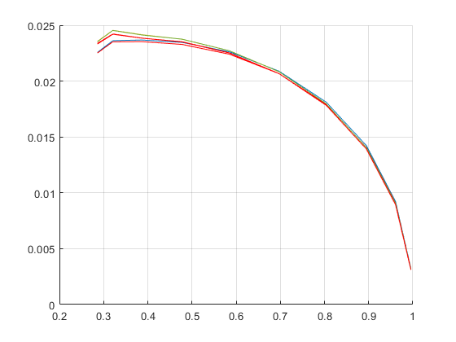
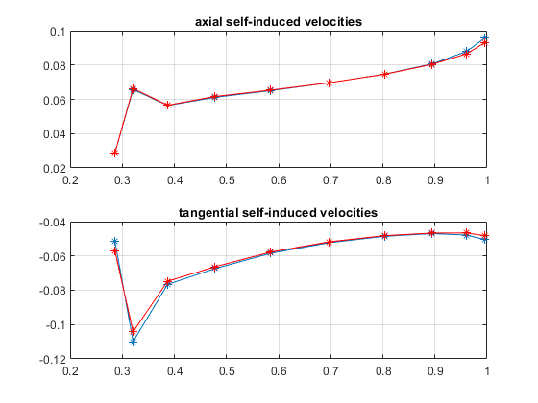
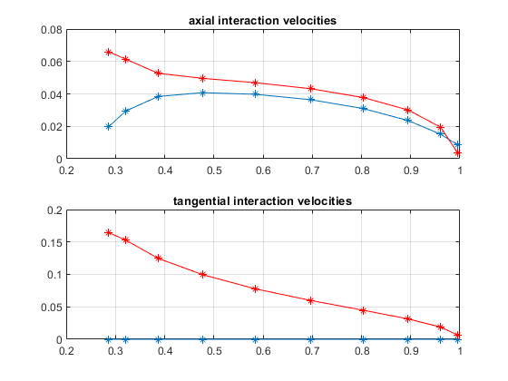
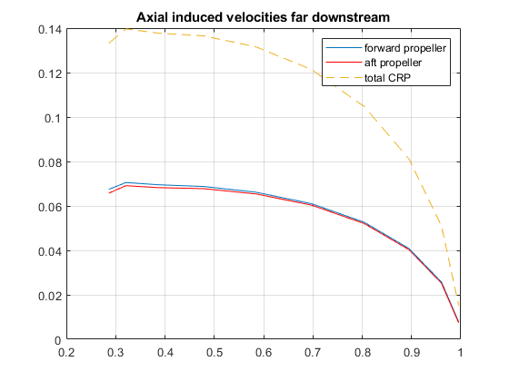
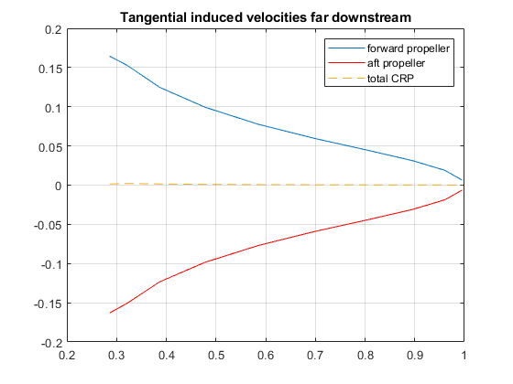
Published with MATLAB® R2021b

